Natalie Stepanenko
Tasha Candela
Career Field Experience
March 8, 2017
St. John Hospital and Medical Center
Introduction
As Henry David Thoreau said best, “Good for the body is the work of the body, and good for the soul is the work of the soul, and good for either is the work of the other” (http://www.quotegarden.com/wise-words.html). I believe that this statement represents much of my aspirations as a professional in healthcare, and my career field experience in the hospital. Caring for the body involves much more than physical needs, and I was happy to be a part of this process over the last 13 weeks. The class revolved around my experience at St. John Hospital and Medical Center in Detroit, MI, and what I have learned by volunteering as a greeter in the Neonatal Intensive Care Unit (NICU) Family Lounge. Throughout the trimester, I worked on Fridays for four hours, greeting the families of ill babies, who were often born premature and not in optimal health. It was my job to identify each visitor as safe to enter the NICU, as well as keep families company in the lounge (and entertain the occasional toddler or two). This course was very different than any I have taken before, as I got to earn credit for gaining experience in a position relevant to my desired career path. Having the opportunity to work in a hospital setting as a high school senior is rare, and was a brilliant way for me to become even more comfortable as a professional individual. More than any other skills, I have been able to display professionalism, adaptability, and a positive attitude at my career field experience. I will demonstrate how these skills were tested and built through the opportunity of taking this class.
Professionalism
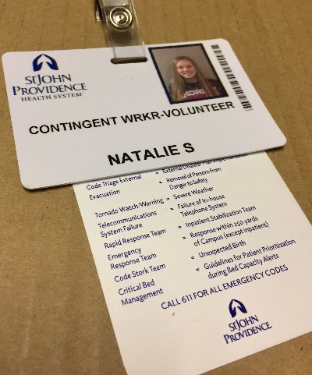
The primary goal of taking this course for me was to become more comfortable in a professional environment, and I am satisfied with the effects I can see in myself after just one trimester. Professionalism is a skill that is enough taught and discussed in our education system, but never truly practiced. Students know the basics of holding a job and what skills are required to become a reliable employee, but they rarely get the chance to form professional relationships or apply their knowledge of the workforce in a setting relevant to their desired career path. Through my career field experience, I had the opportunity to both test my compatibility with a hospital setting and develop rapports with my superiors and peers in the NICU and at the volunteer office. Always dressed in business casual and displaying my badge on my blue St. John volunteer’s jacket, I felt important and confident that I could help people who needed it. I was often asked what college I attended, then greeted with surprise when I responded that I was only a high school senior. Everyone from parents to nurses and other volunteers often expressed how convinced they were that I was older, which is a comment that I do not commonly receive. I believe that this was because of the level of professionalism I displayed, which is something that I am quite proud of. After experiencing the opportunity to express my professionalism on a regular basis, I am more confident in myself as an employable individual.
Adaptability
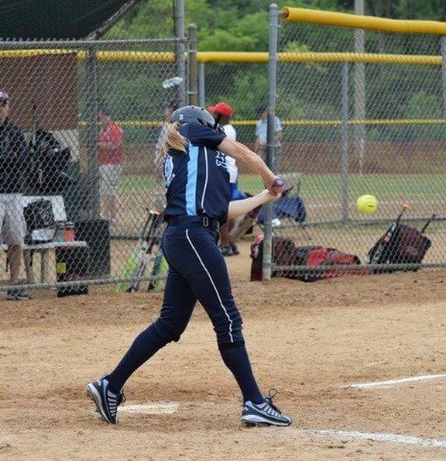
Throughout my time in the hospital, situations arose where I was unsure of what to do. From forgetting my badge and getting lot on the way to lunch on my first day, to calling nurses to confirm that visitors could go back to the NICU, I had to use my problem solving skills and adapt to challenges as they revealed themselves. Adaptability is crucial, both in a career and in life, because there will not always be instructions laid out for you saying what the right thing to do is. Being creative and coming up with appropriate responses to new scenarios is a skill that will always be useful, so getting the chance to practice this was a unique opportunity that I did not think of coming into this course. As an athlete, adaptability is a skill that is stressed as a key to being successful. Translating this into a professional setting was a task that I felt quite comfortable doing. I definitely feel more prepared to immerse myself in things that I normally would not have thought of before because of this class. A good example of this would be my interview for my next placement at a physical therapist’s office. Coming into the interview, I was getting very nervous thinking about being by myself in a new place, talking to the owner of the office. However, after I remembered how much experience and confidence I have in a setting like a medical office, all I needed was a deep breath for the interview to go off without a hitch. I adapted to the situation, where I was unsure of what to expect, and made the best of it, turning my nerves into excitement. I am grateful for the opportunities I had in this course, which have allowed me to ease my way into the process of finding new employment and adapting to new situations.
Positive Attitude
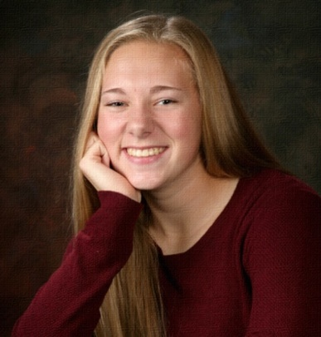
Dealing with the parents of ill newborns seems like it would be quite challenging, but with a positive attitude, almost all of the visitors I encountered seemed to be in good spirits. Uplifting their moods and bringing a smile to these parents’ and family members’ faces was always my biggest goal in the NICU, since I can only imagine how difficult each individual situation was. Occasionally, I would have rewarding conversations with parents who stayed in the lounge. For example, I met a man visiting his newborn child with his wife and young daughter. While the wife visited their baby, the father stayed to watch his daughter. He started asking me about myself, and we had a good discussion about being successful and life in general. I learned that he had emigrated from the Philippines to have a better life, and that the mother of his daughter was not the woman he was with, but that she had passed away. I learned a few lessons from this man about staying positive and dealing with life’s hardships with a smile. Without greeting this man with a positive attitude, I may have never had the chance to speak with him, and I would have missed out on a conversation that I will cherish from my time at the hospital. I believe that every decision we make has an effect on the rest of our future, and that choosing to be happy amidst adversity is one of the most important choices of all. A simple smile or a small good deed can change a life, so to have the chance to brighten the days of these strong families was a very rewarding experience that I will always appreciate.
Final Evaluation Reflection
I was a little surprised when I saw some of the scores that I received on my evaluation sheet, but then I realized that this is because my supervisor never really even saw me. Quite honestly, I'm not 100% sure that the woman I spoke to on Friday was Laura. That being said, I did not really take my evaluation to heart, since I got marked down in categories such as "He/she demonstrates a positive attitude when interacting with patients/public clients". I know that if I was well supervised, my evaluation would have looked different. Still, I wish I would have gotten better ratings on my sheet, especially in the categories I was rated a 3 in.

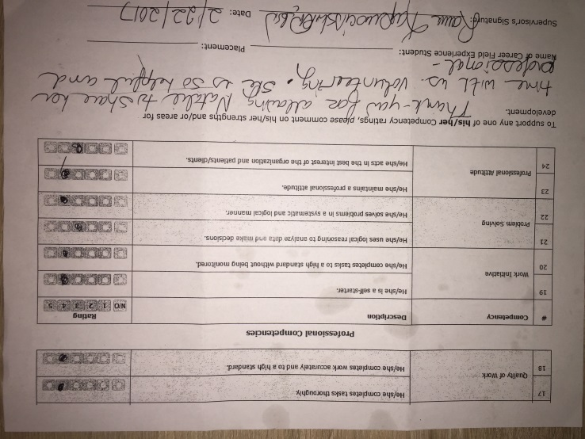
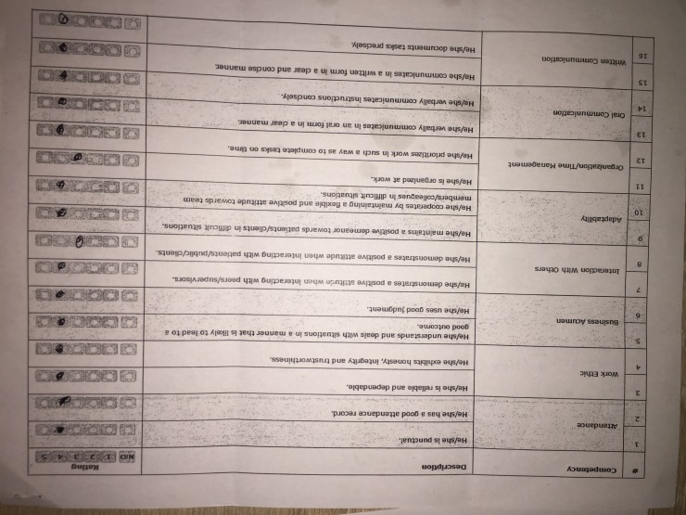

Conclusion
After gaining the practical experience and professional skills that come with taking this class, I have learned so much more about myself and my desires concerning my future career path. Coming into this course, my mind was set on going into a field of medicine far from any patients or families; I was stubbornly focused on avoiding contact with strangers in the workplace. When this opportunity to see the other side of healthcare that deals solely with the families of patients arose, I was undoubtedly hesitant. However, looking back, it is clear to me that I made the right choice in stepping outside of my comfort zone. I have a new perspective on patient care, and the complex support system that each patient may or may not have. The bonds of my own personal relationships have strengthened because of how constantly I was reminded that it is the people in your life that truly matter most. The lessons I have learned in this class stretch far beyond what any textbook could teach a student about life after high school and I would not change one thing about my career field experience. I am more confident than ever in my plans to pursue biochemistry, and I am looking forward to finding the career that is right for me through opportunities such as this course.

